ONEWAY CRT BY HAD
/STATISTICS DESCRIPTIVES HOMOGENEITY WELCH
/PLOT MEANS
/MISSING ANALYSIS.

Oneway

Notes
Output Created |  | 05-May-2019 23:35:06
Comments
Input | Active Dataset | DataSet0
Input | Filter | <none>
Input | Weight | <none>
Input | Split File | <none>
Input | N of Rows in Working Data File | 30
Missing Value Handling | Definition of Missing | User-defined missing values are treated as missing.
Missing Value Handling | Cases Used | Statistics for each analysis are based on cases with no missing data for any variable in the analysis.
Syntax |  | ONEWAY CRT BY HAD  /STATISTICS DESCRIPTIVES HOMOGENEITY WELCH  /PLOT MEANS  /MISSING ANALYSIS.
Resources | Processor Time | 00 00:00:00.156
Resources | Elapsed Time | 00 00:00:00.158

[DataSet0]

Descriptives
 | N | Mean | Std. Deviation | Std. Error
1-4 hours per day | 10 | 9.8400 | 2.86868 | .90716
4-8 hours per day | 6 | 9.9500 | 3.78827 | 1.54656
Less than an hour a day | 9 | 6.7333 | 3.07896 | 1.02632
More than 8 hours per day | 5 | 8.0800 | 3.14516 | 1.40656
Total | 30 | 8.6367 | 3.32291 | .60668

Descriptives
 | 95% Confidence Interval for Mean |  | Minimum | Maximum
 | Lower Bound | Upper Bound | Minimum | Maximum
1-4 hours per day | 7.7879 | 11.8921 | 4.40 | 12.40
4-8 hours per day | 5.9745 | 13.9255 | 4.50 | 14.00
Less than an hour a day | 4.3666 | 9.1000 | 3.20 | 11.60
More than 8 hours per day | 4.1748 | 11.9852 | 5.00 | 13.20
Total | 7.3959 | 9.8775 | 3.20 | 14.00

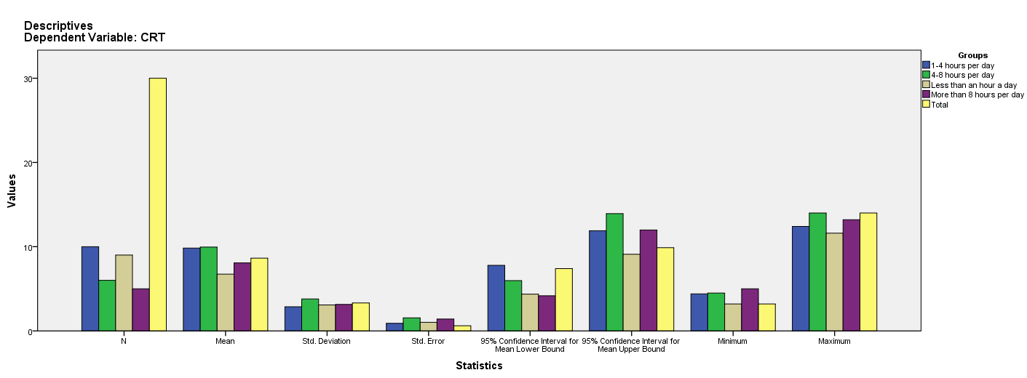

Test of Homogeneity of Variances
CRT
Levene Statistic | df1 | df2 | Sig.
.384 | 3 | 26 | .765

ANOVA
CRT
 | Sum of Squares | df | Mean Square | F | Sig.
Between Groups | 58.983 | 3 | 19.661 | 1.957 | .145
Within Groups | 261.227 | 26 | 10.047
Total | 320.210 | 29

Robust Tests of Equality of Means
CRT
 | Statisticª | df1 | df2 | Sig.
Welch | 1.819 | 3 | 11.759 | .198
a. Asymptotically F distributed.

Means Plots

